

Submitted by

**KABIR KOLI 2K19/IT/064**

**MALAY RAJ 2K19/IT/074**

**DS PROJECT REPORT**

**Submitted to**

**RITU AGARWAL MAM**

**DEPARTMENT OF INFORMATION TECHNOLOGY**

**DELHI TECHNOLOGICAL UNIVERSITY**

**(Formerly Delhi College of**

**Engineering) Bawana Road, Delhi-**

**110042**

PASCAL’S TRIANGLE

**WHAT IS IT ?**

In mathematics, Pascal's triangle is a triangular

Array of the

binomial coefficients.

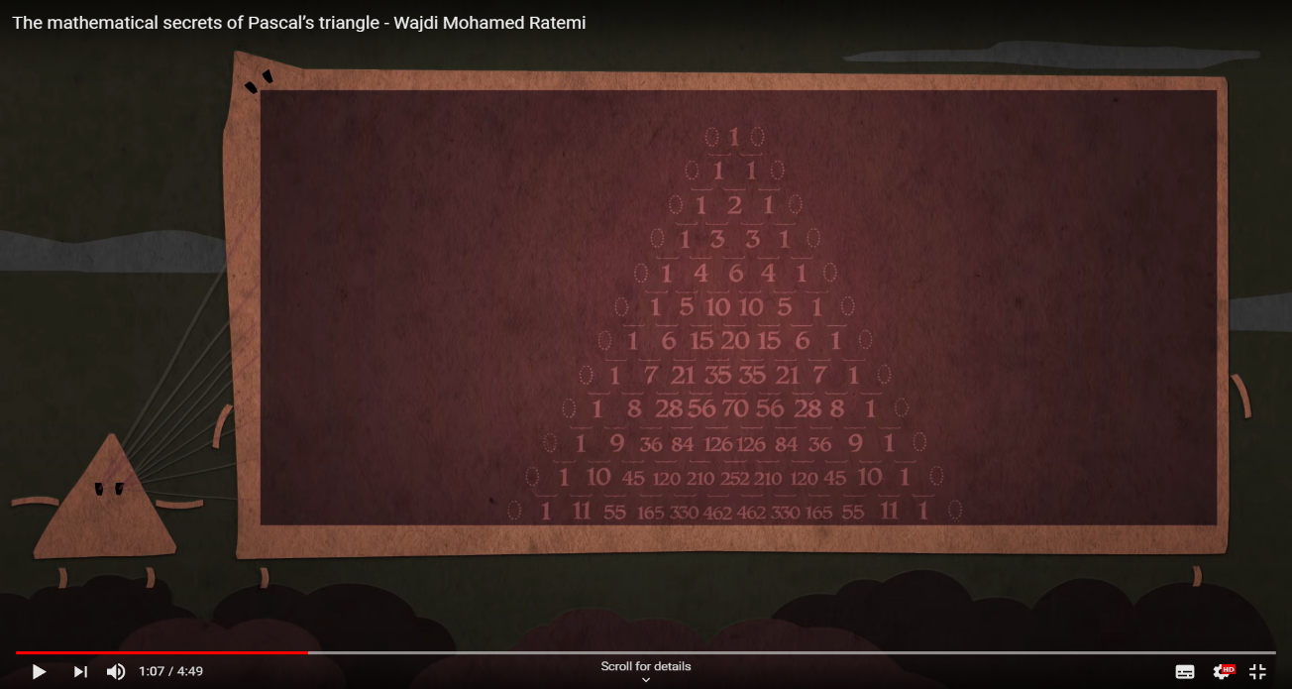

This might be looking arranged

numbers but in mathematics

this is a treasure.

Indian mathematicians called it **staircase of mount meru** (HALLAYUDH)

In Iran its **Khayyam’s triangle** (1048 – 1131CE)

In China its **Yang hui’s triangle** (1238 -1298 Ce)

But in WESTERN WORLD , it is known as **Pascal’s triangle** (1623 -1662 CE)

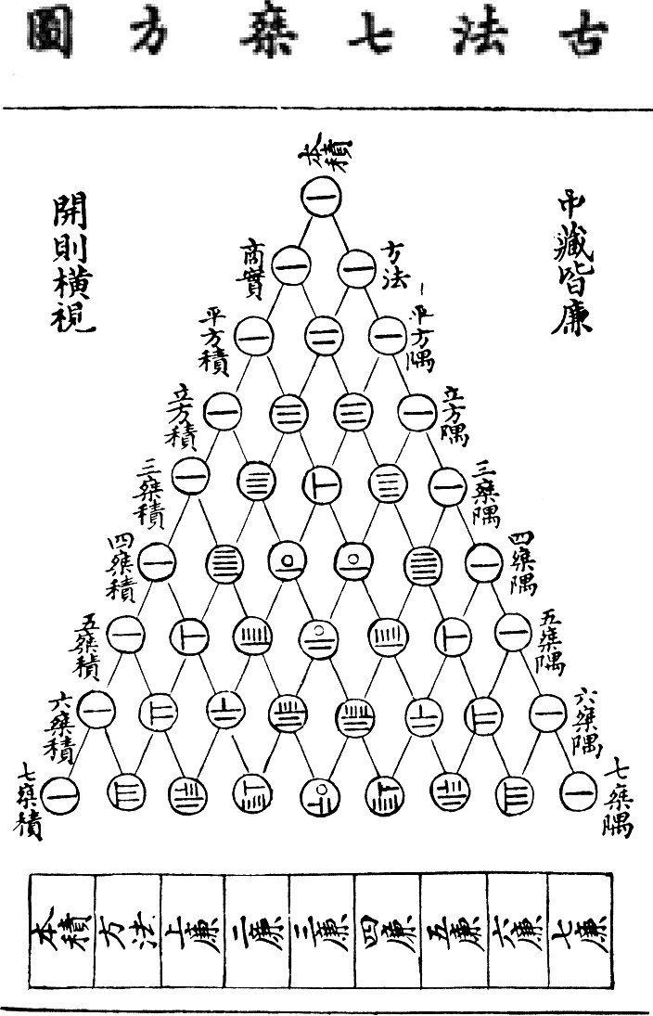

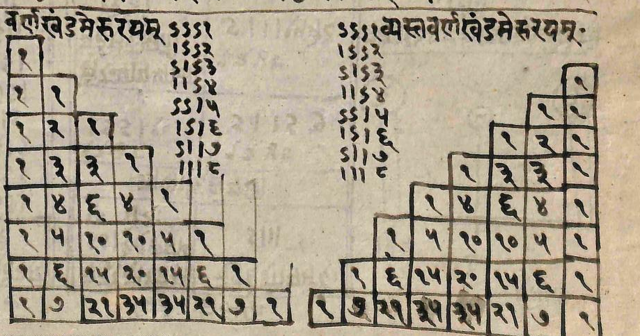

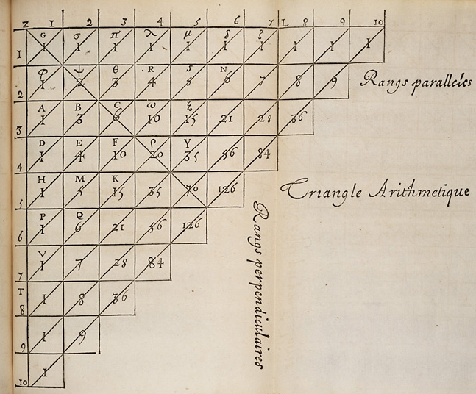

Let us now look at some interesting facts   
about this triangle



1.Geometrical applications

2. Circles , Vertex , Edges and Quadrilaterals

3. Sum is 2n

4. Relation with 11n

5.(x+y+w+z…)n

6.Sierpinski’s triangle

Geometrical applications

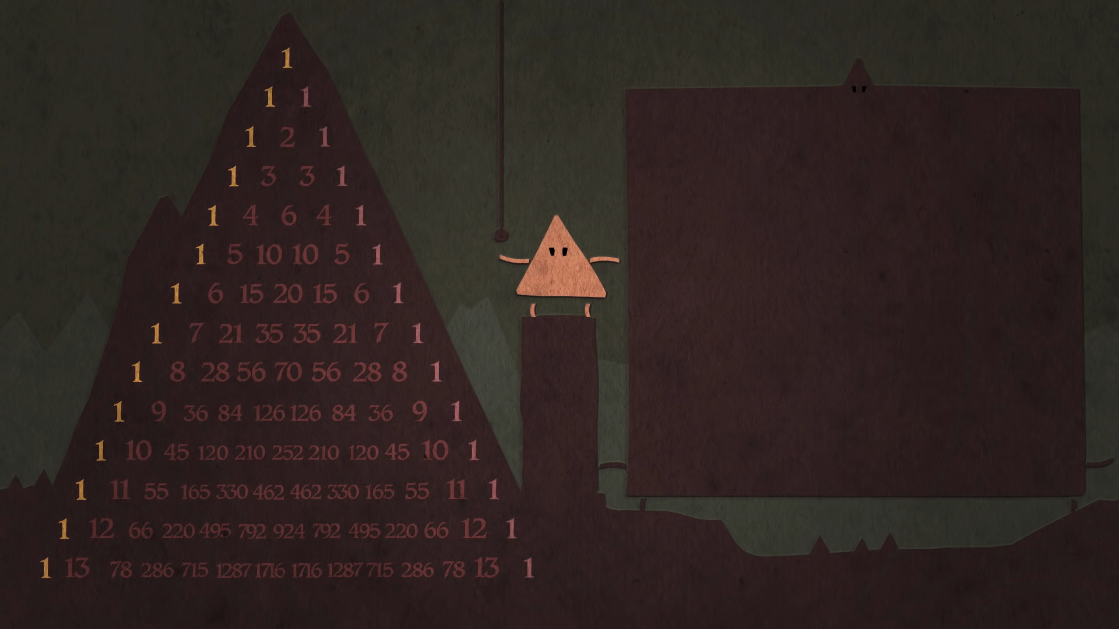Here take a closer look at the diagonals , they are very interesting

First one is simple all 1’s ,

second one all positive integers what we call

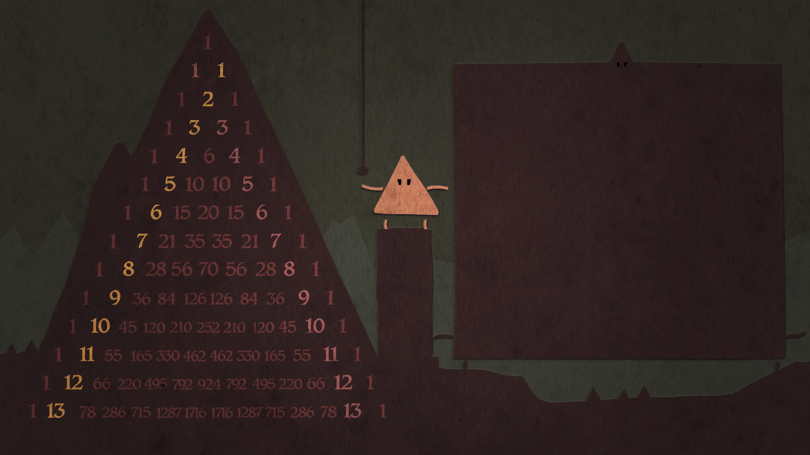as natural numbers .

Third one’s are what we call **triangular** numbers, they

are special because you take that many dots, you

can stack them in equilateral triangles.

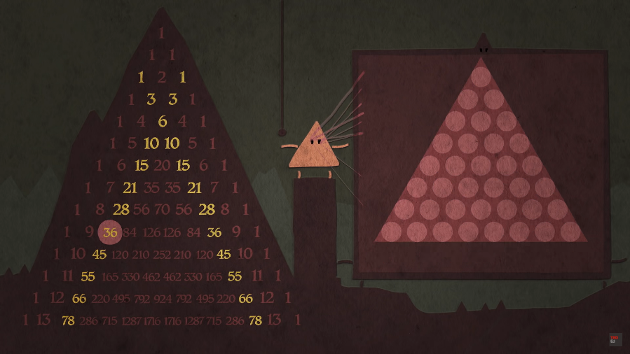

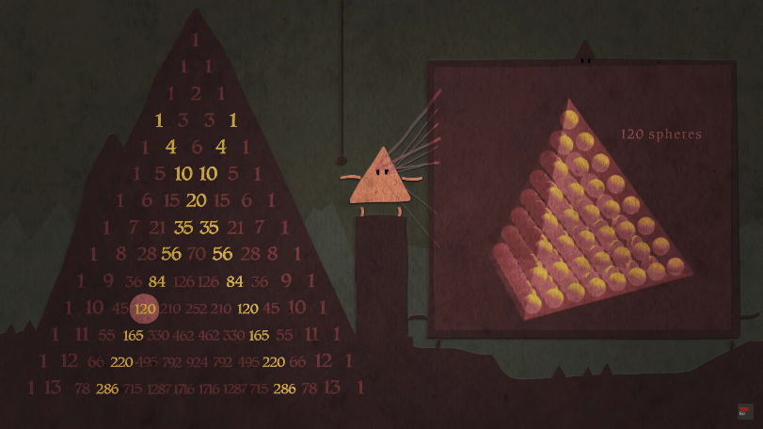

Next numbers are what we call **Tetrahedral**

numbers, if you take that many dots then you can

stack them into tetrahedral.

1st APPLICATION

TOWER OF HANOI

AN ANCIENT PUZZEL



BEGINNING AUXILLARY END

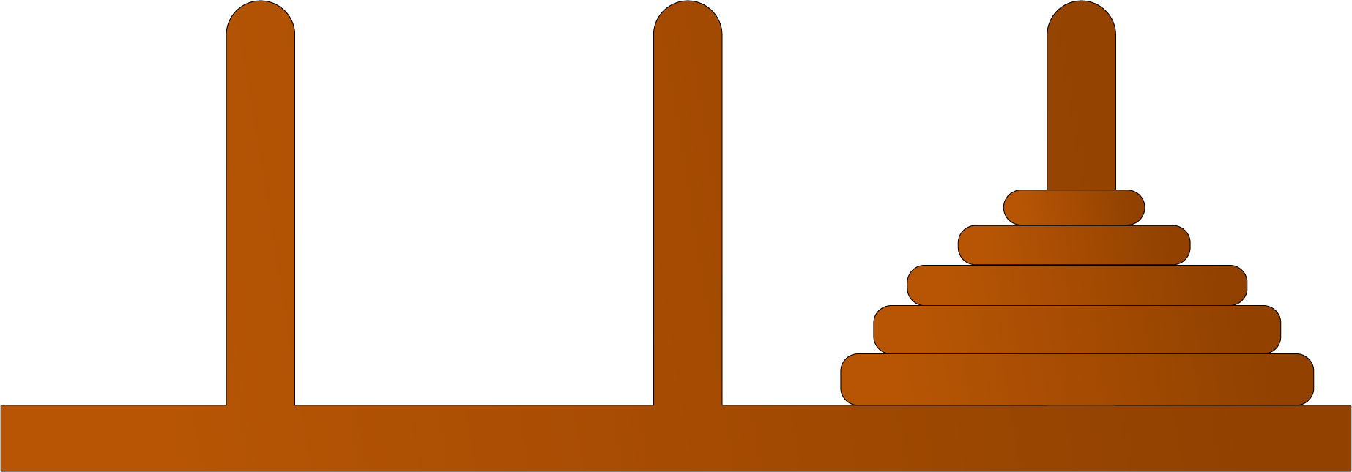

BEGINNING AUXILLARY END

The Tower of Hanoi is a mathematical game or puzzle. It consists of three rods and a number of disks of different sizes, which can slide onto any rod. The puzzle starts with the disks in a neat stack in ascending order of size on one rod, the smallest at the top, thus making a conical shape.

The objective of this problem is to move the stack of disks from the initial rod to another rod, following these rules

* A disk cannot be placed on top of a smaller disk

The goal is to move all the disks from the leftmost rod to the rightmost rod. To move n disks from one rod to another, 2n−1 steps are required.

* Used in real life

The Tower of Hanoi is commonly used by psychologists to research and examine problem solving skills. Problem solving skills can be acquired by calculating moves and strategies while at the same time predicting possible outcomes. The recursive rule of the Tower of Hanoi is studied and applied in computer programming and algorithms which helps to reduce the amount of time it takes to create a program.

Relation of TOH with PASCAL’S TRIANGLE

As we now for n disks we need 2n−1 moves that’s simple but we have another simple way to find out solution of this problem that is PASCAL’S TRIANGLE.

The sum of first n rows of PASCAL TRIANGLE (from 0 to n-1 ) is the number of moves needed to

move n disks from one peg to another in TOH

For example, if n=3 means there are 3 disks then we 7 moves.

But here in PASCAL’S TRIANGLE look from row 1 (that is row no. 0)

to row 3 (that is row no.2) and add all the numbers, those are

1+1+1+1+2+1=7.

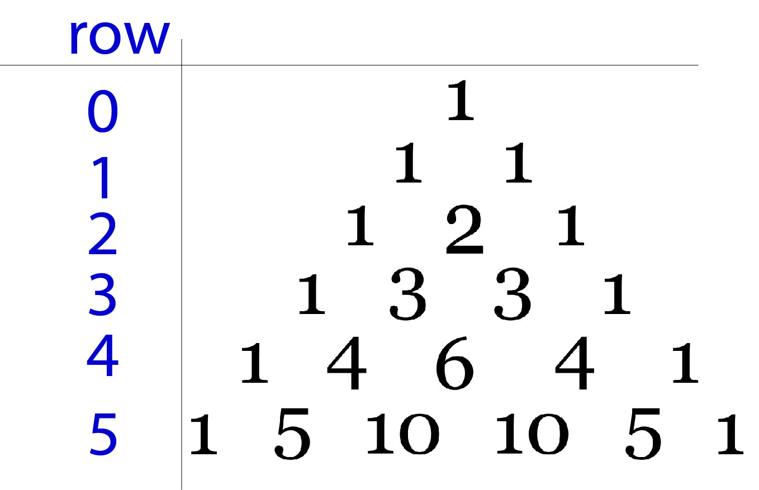

Here pascal triangle is related to most of the other concepts in mathematics , this is not a coincidence I think . Well , let us see those concepts or interesting facts .

Number one , let’s take a closer look at

Those numbers , what if we add all the

Numbers in a row and see the result .

One might not get it at once but the result

Is in **2n**

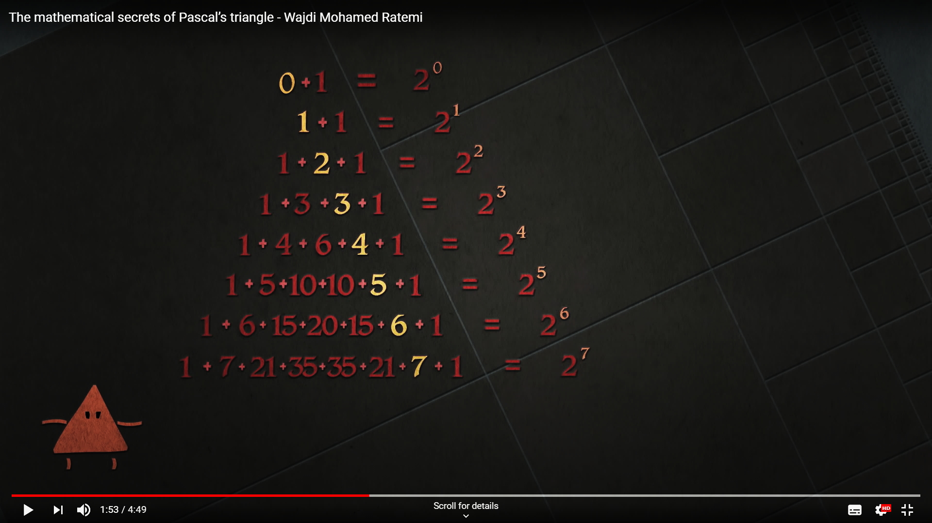

Second let us look at this circle

for n=4 in the pascal’s triangle numbers are **1 4 6 4 1**

In this figure there are 4 vertices which matches

With our number 2 .

6 represents the number of edges in the fig.

There are 4 triangles here

And 1 quadrilateral .

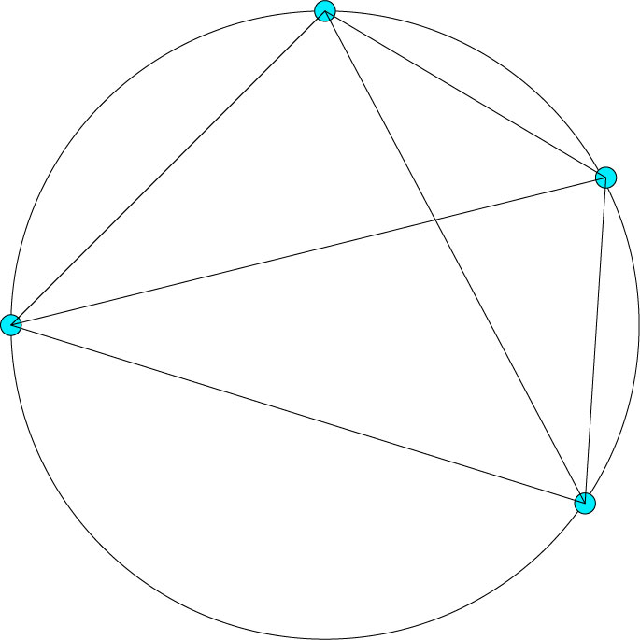

2nd APPLICATION

PROBABILITY

Suppose we want to find the probability of

have n children's but m of them are girls

and n of them are boy . It can be done

easily with the help of PASCAL’S

TRIANGLE

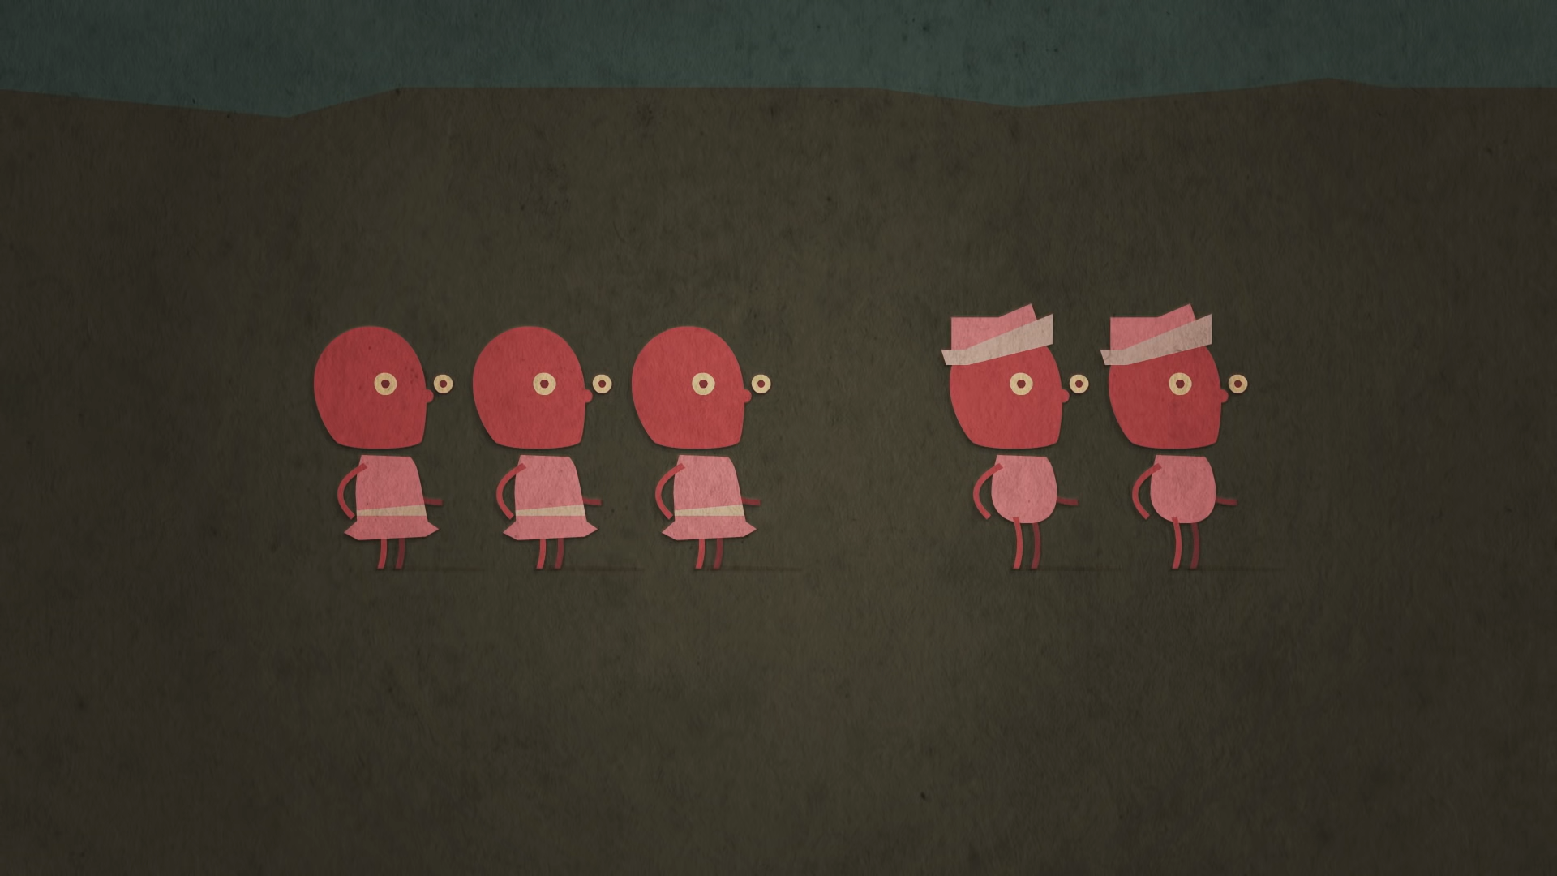

Or Suppose you want to find the probability of having m heads in

n tosses ,this can be done using PASCAL’S TRIANGLE

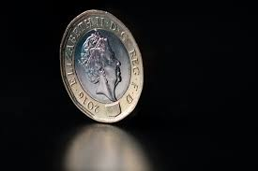

* CHILDREN

Suppose one want to have 5 children's ,

3 of them are girls and 2 of them are boys ,

then it is in the 5th row and 2nd column

we get 10.

Now add the numbers in the 5th row that is 32

and divide them.

Probability of having 3 girls and 2 boys is

10/32=31.25%.

It also gives us the number of combination

of having different boys and girls .

For example there are 10 ways one can have 3 girls and 2 boys.

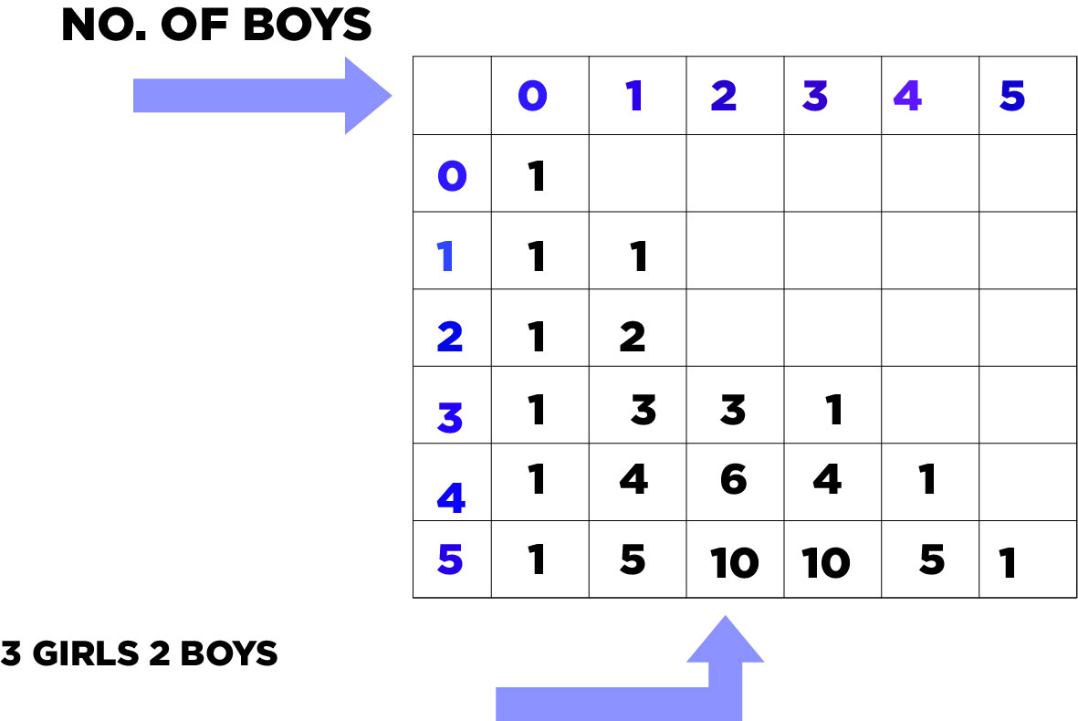

NO. OF CHILDRENS

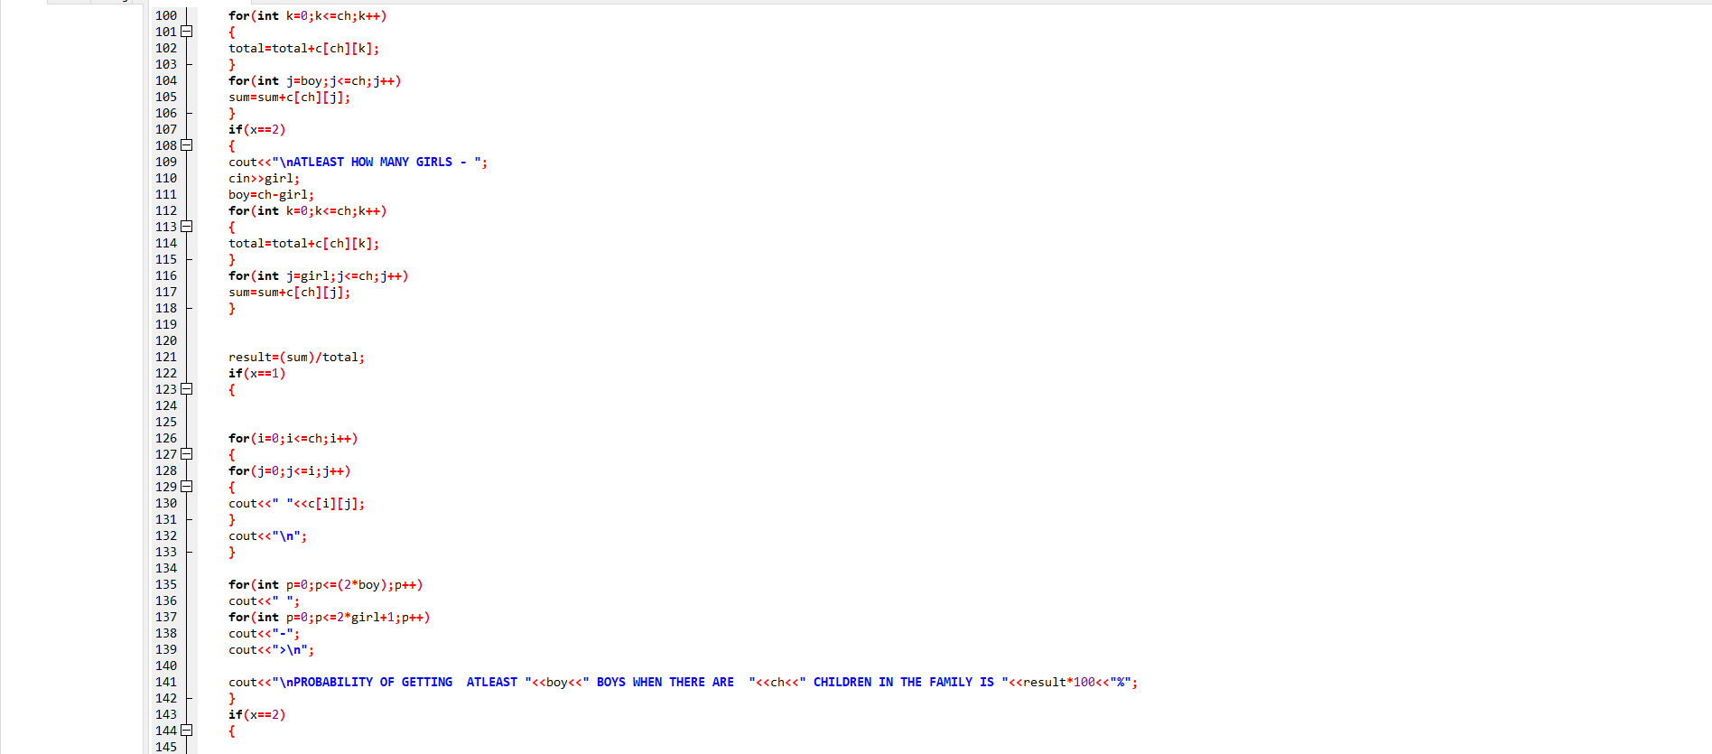

* COIN

Suppose one tosses n coins then PASCAL TRIANGLE

can be used to find the

probability of finding m heads/tails.

For example one want to find the probability of having

2 heads in 4 coins tosses, number outcome will

be 1+4+6+4+1=16.

for 2 heads go to row 2 and column 4 there we have a number (6)

6/16=37.5%

We also have the number of combination of how many samples will

be there of having 2 heads this is 6.

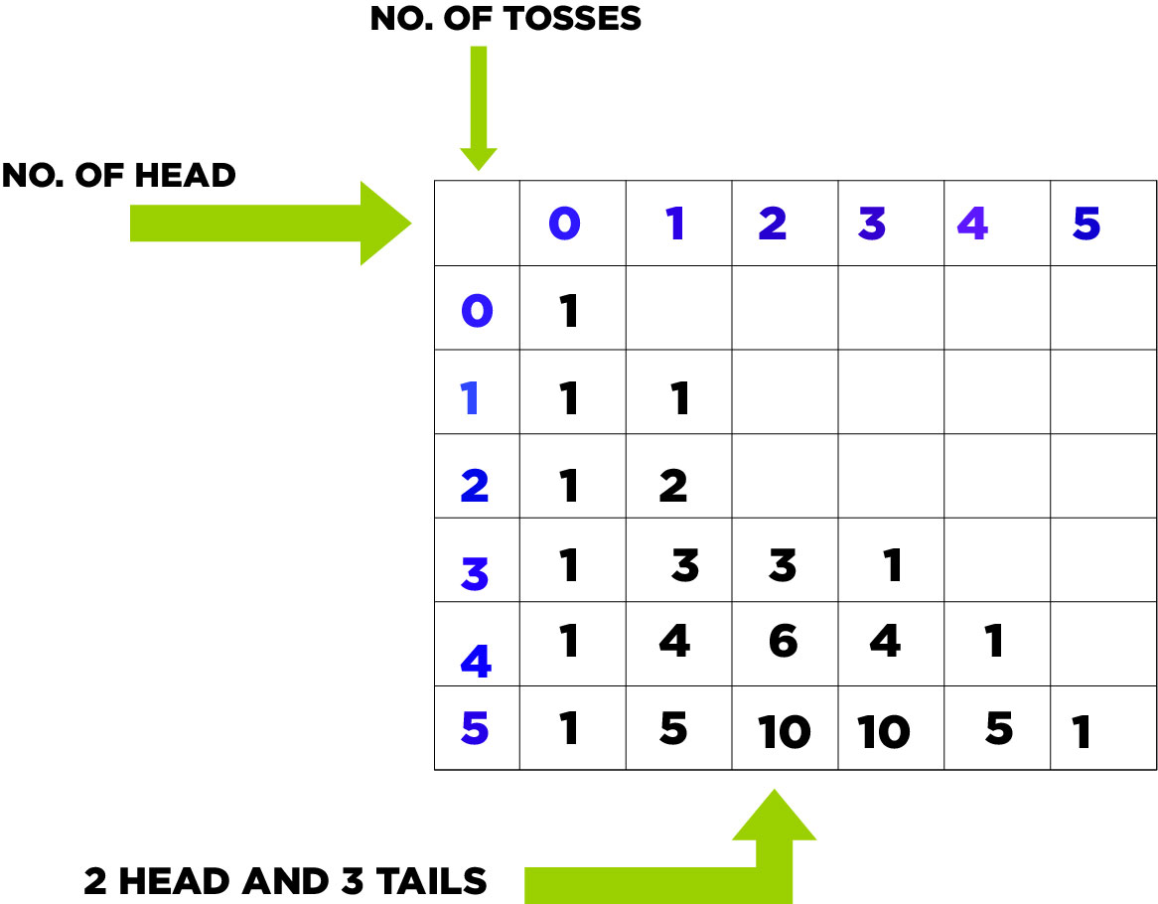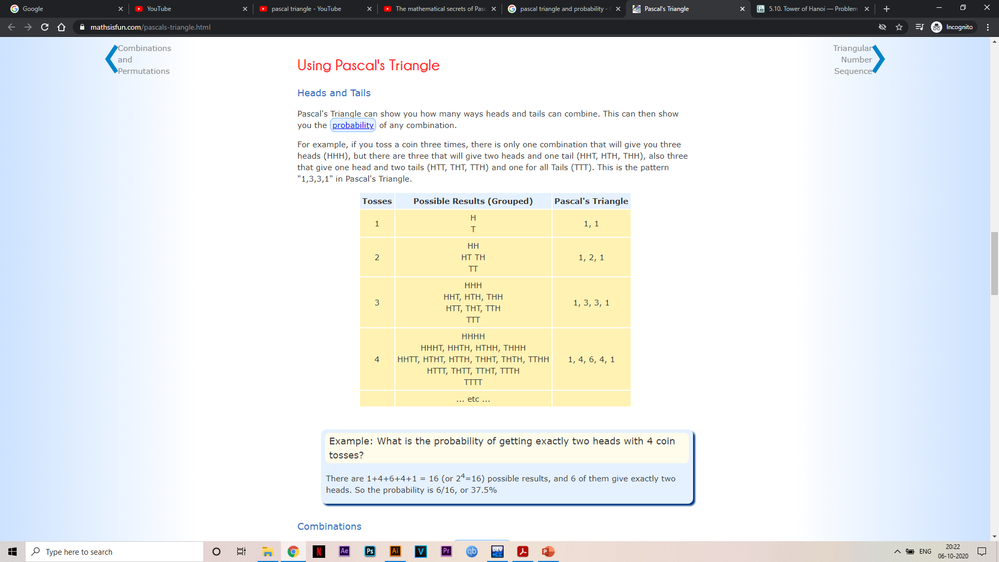

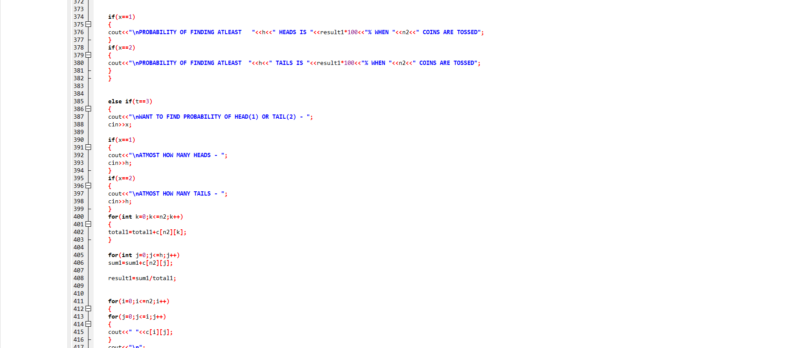

* Sierpinski’s triangle

If we make all the odd numbers black in colour and all

the even number white in colour then a pattern will form

that is shown here. This pattern is also know as

Sierpinski’s triangle

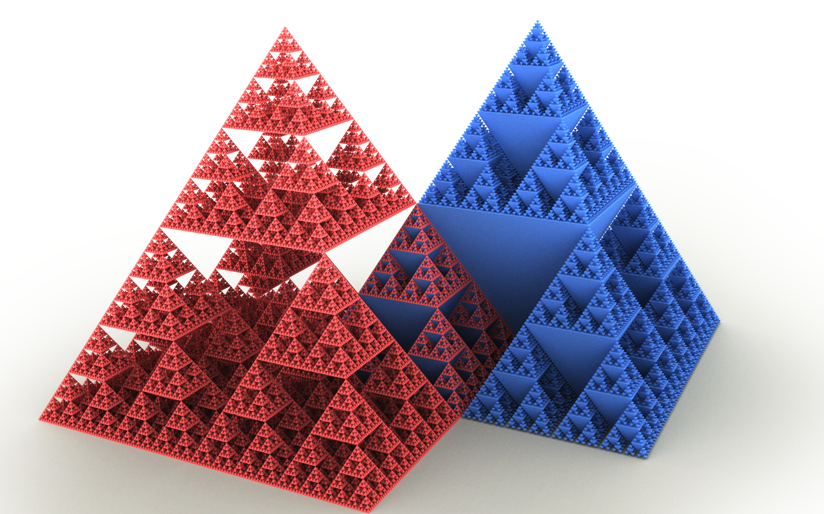

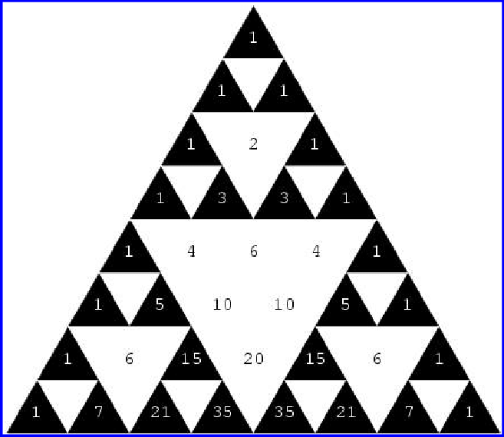

* 3nd APPLICATION

BINOMIAL EXPANSION

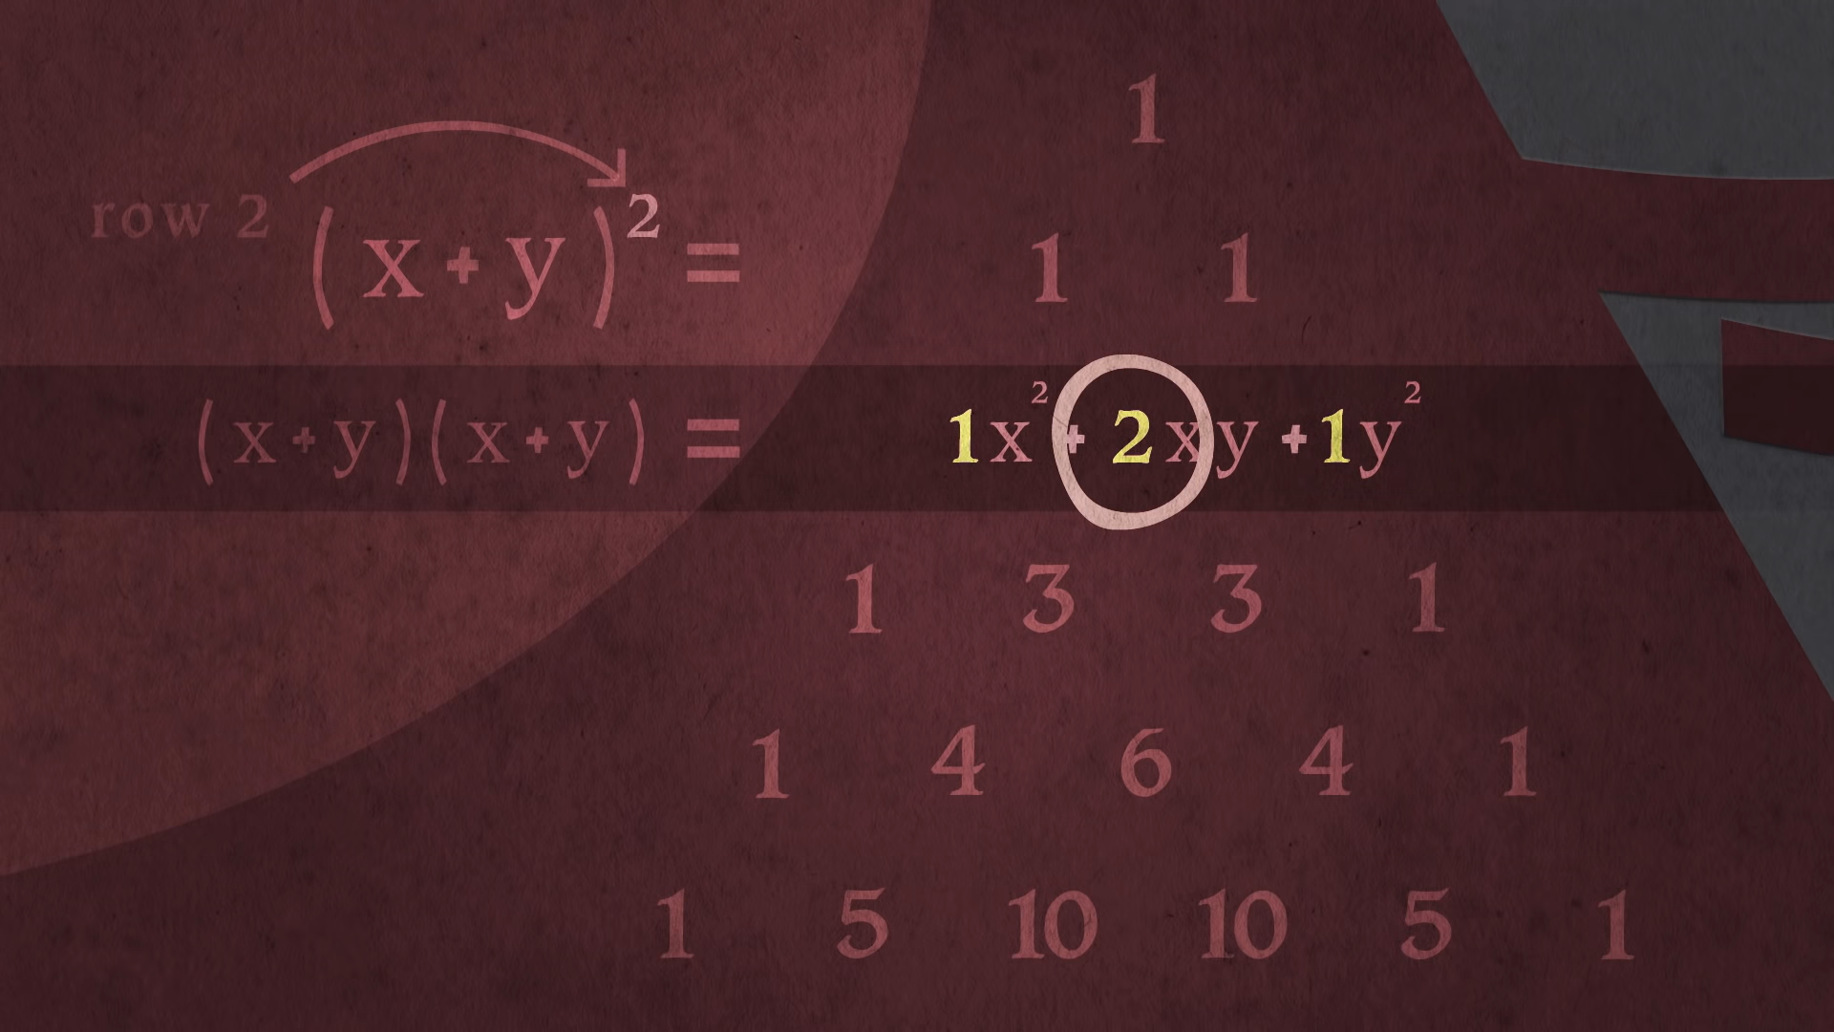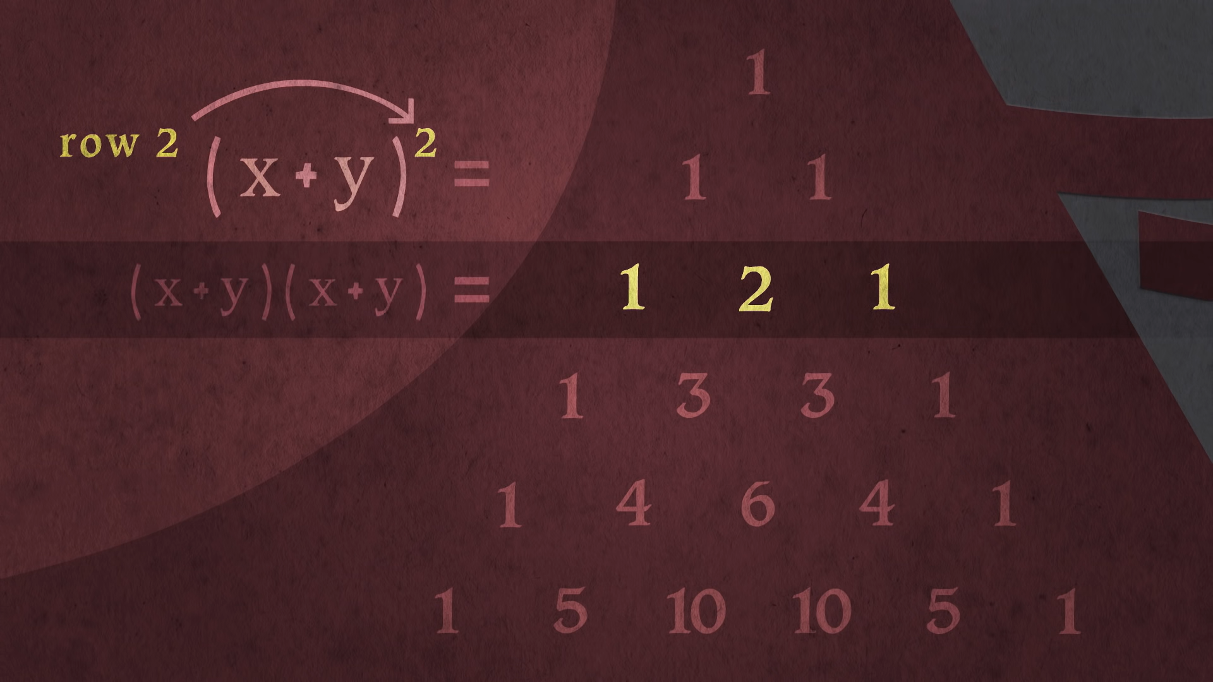

The binomial theorem (or binomial expansion) describes the algebraic expansion of powers of a binomial.

According to the theorem, it is possible to expand the polynomial  **(x + y)n** into a sum involving terms of the form **axbyc**, where the exponents b and c are nonnegative integers with **b + c = n**, and the coefficient a of each term is a specific positive integer depending on n and b.

For example (for n = 3),

1x3+3x2y+3xy2+1y3 is the binomial expansion.

Economists used **binomial theorem** to count probabilities that depend on numerous and very distributed variables to predict the way the economy will behave in the next few years. To be able to come up with realistic predictions, **binomial theorem** is used in this field.

* 4th Application

NUMBER OF COMINATIONS

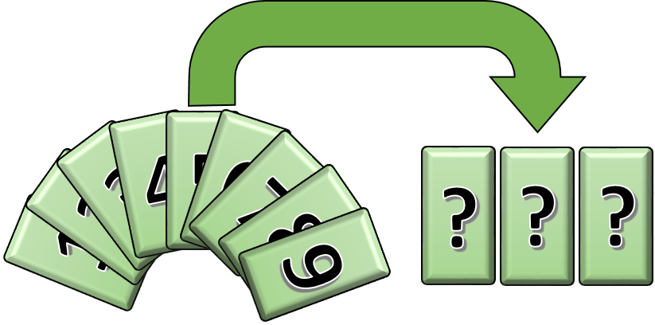



In mathematics, a combination is a selection of items from a collection, such that the order of selection does not matter.

If I want to select 2 players for my team from

5 players , this can be done easily by a

Mathematical formula that is nCr

nCr = n!/r!(n-r)! , where ! Is factorial means

5!=5*4*3*2*1.



* Relation of Combination with PASCAL’S TRIANGLE

As we have seen in the previous slides there is some mathematics involved in this formula

nCr , suppose someone is doing some math problem and he is facing this formula again and

again so , this might be very difficult for him to find nCr by the method given. And here

PASCAL TRIANGLE comes into picture by using pascal’s triangle one can easily tell the answer just by looking at it ( PASCAL TRIANGLE) .

For example , let us take our previous problem where we were choosing 2

players from 5 , it can easily be solved just by looking at the pascal triangle

n represent the number of row and r represents the number of column

checking pascal triangle’s 5 row and 2 column we get our answer.

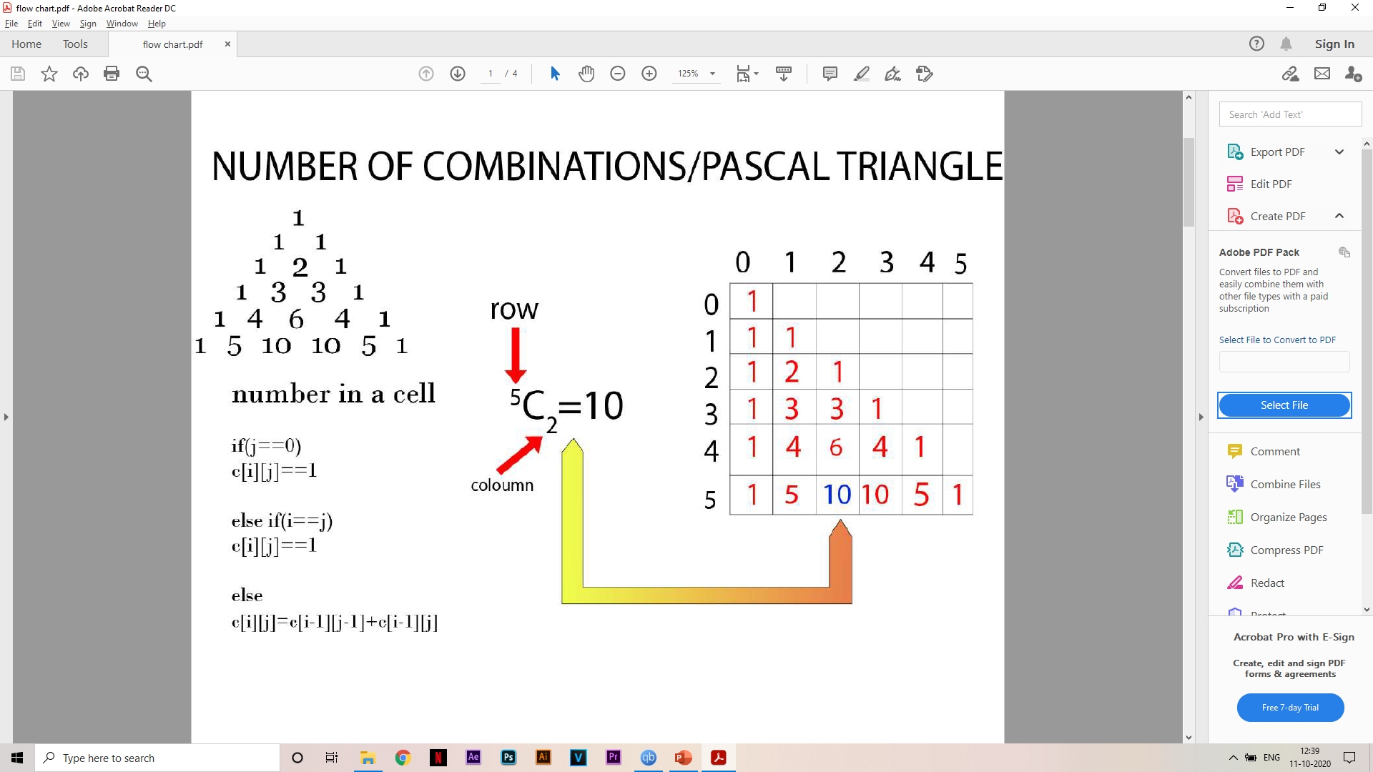

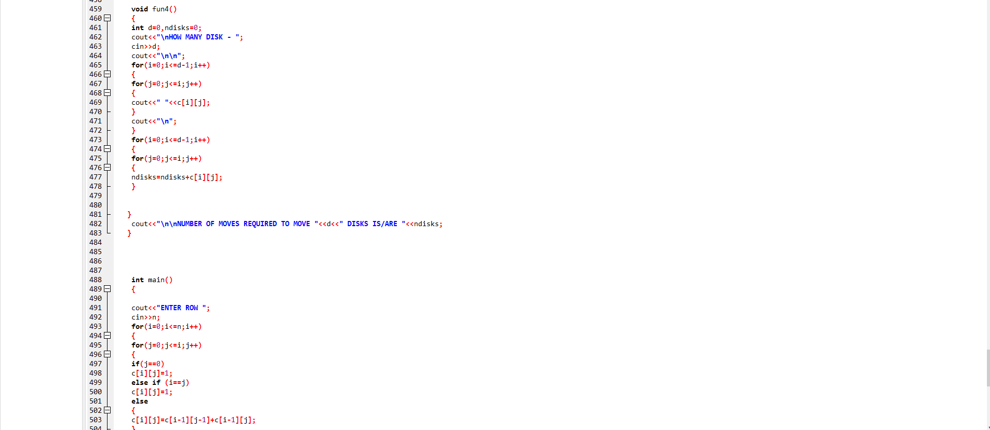

* Used in real life

Every one uses combination unintentionally in day to day life for example selecting cricket team or any kind of situation where someone is choosing something .

THANK YOU